**Module**

**in**

***PATHFit 1 (MIDTERM)***

**Physical Activities Toward Health and Fitness 1 (Movement Competency)**

1st Semester 2023-2024

Prepared by:

Amaranto, Jeff C.

Baligat, Loraine G.

Cabacungan, Nina A.

Talania, Aldrin S.

**UNIT 3**

**Breathing and Bracing, Exercise Variables and Principles**

**Breathing and Bracing**

**Breathing**

The process that moves air in and out of the lungs is called breathing or pulmonary ventilations. It is one of the processes that deliver oxygen to where it is needed in the body and remove carbon dioxide.

**Organs that involved in Breathing:**

* Nose
* Trachea
* Bronchi
* Bronchioles
* Lungs
* Muscles along with diaphragm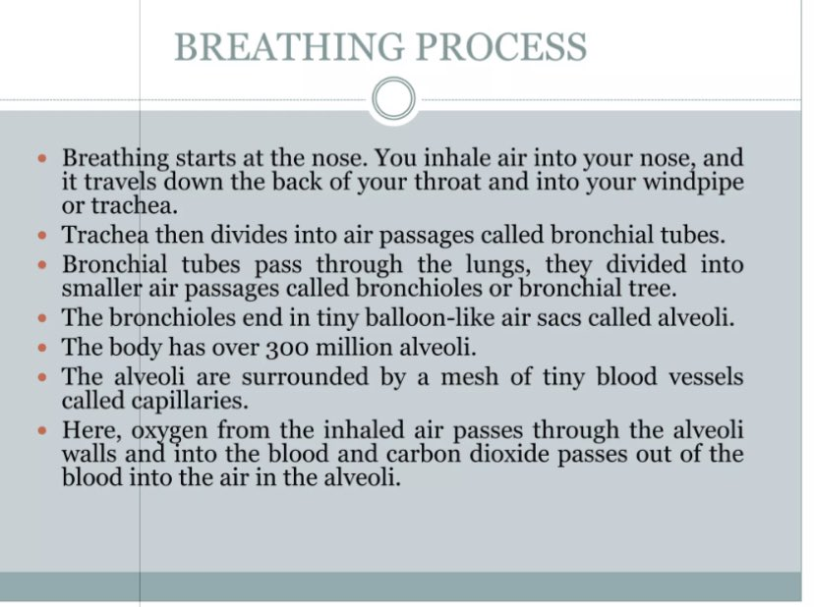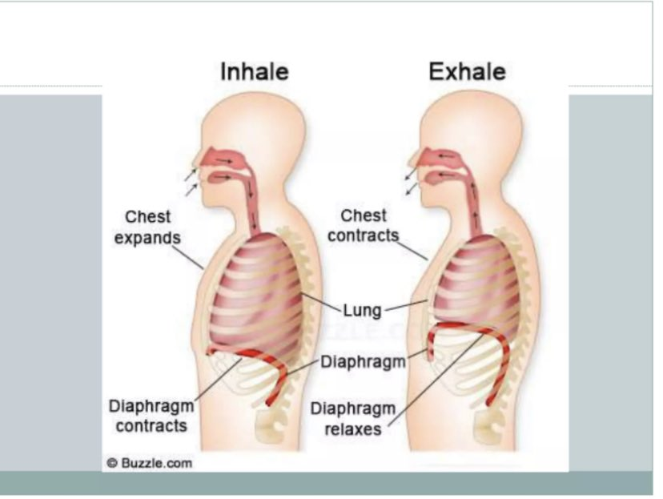

**Bracing**

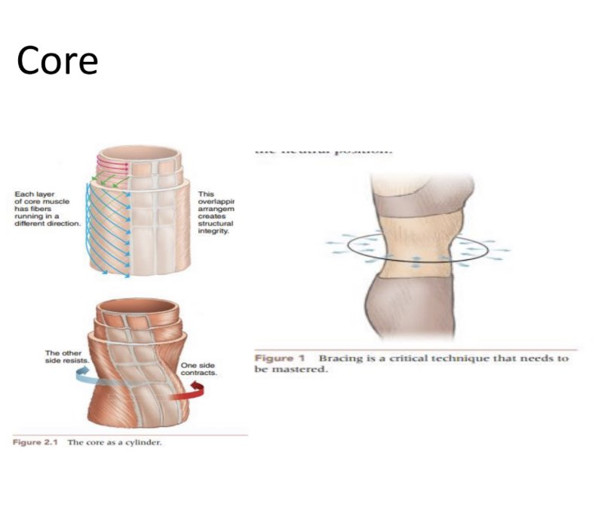Bracing is the process of creating and raising 360 degrees of intra-abdominal pressure to engage the core's muscles and keep the spine in the ideal posture when moving or being exposed to stress.

**Exercise Variables**

Exercise variables help us understand the current routine and its effects. Individuals may be unaware of or have not considered the variables that influence exercise and, ultimately, results. Many factors influence your training, but understanding the variables in particular can help you achieve better fitness results. Your understanding of the exercise variables will assist you in making the most of your exercise efforts.

**1:**[***Exercise selection***](https://www.newbodyplan.co.uk/training/hypertrophy/7-workout-variables/#Exercise-Selection) The different exercises or lifts you perform in a workout, which determines which muscles you train in that session  
**2:**[***Exercise order***](https://www.newbodyplan.co.uk/training/hypertrophy/7-workout-variables/#Exercise-Order) The order in which you perform the exercises in an workout  
**3:**[***Sets***](https://www.newbodyplan.co.uk/training/hypertrophy/7-workout-variables/#Sets) The number of times you perform a group of reps (short for repetitions)  
**4:**[***Reps***](https://www.newbodyplan.co.uk/training/hypertrophy/7-workout-variables/#Reps) The number of times you perform an exercise without stopping for rest  
**5:**[***Tempo***](https://www.newbodyplan.co.uk/training/hypertrophy/7-workout-variables/#Tempo) The speed at which you perform each rep  
**6:**[***Rest***](https://www.newbodyplan.co.uk/training/hypertrophy/7-workout-variables/#Rest) The time you have to recover between sets and and between exercises  
**7:**[***Weight***](https://www.newbodyplan.co.uk/training/hypertrophy/7-workout-variables/#Weight) The amount of resistance you lift for each set

**Principles Of Exercise**

The exercise principles outline the criteria that guide all training.  Each principle allows us to critique some element of a person’s training.  When a person’s training follows the principles well it is most likely to be successful.  Following is a list of the principles and their definitions.

|  |  |
| --- | --- |
| **PRINCIPLES OF EXERCISE** | **DEFINITION** |
| **Principle of Specificity**  **(MIMIC THE MOVEMENT)** | Any change or adaptation in the body’s muscles, organs and systems will be very specific to the type of training undertaken. |
| **Principle of overload**  **(Experiencing beyond expected)** | To bring about any adaptation the body will have to work a little harder than it is used to. |
| **Principle of Reversibility**  **(Used it or lose it)** | Improvements in fitness can be maintained by regular exercise and activity. If training stops the benefits gained will gradually decline. |
| **Principle of Adaptability/Variety**  **(Add diversity to training)** | For optimal adaptation and to avoid stagnation, overuse, and injury the exercise stimulus must be varied (this does not simply mean changing exercises all the time). |
| **Principle of Individuality**  **(Different strokes to different folks)** | There are many factors that will affect an individual training potential   * Age * Gender * Body type * Heredity * Muscle fibre type * Range of motion * Strength * Cardiovascular fitness |
| **Principle of Recovery time** | Rest and recovery time is essential to prevent overtraining. |
| **FITT Principle**  **F-REQUENCY**  **I-NTENSITY**  **T-IME**  **T-YPE** | How often the activities will be performed.  How hard the activities will be.  How long the activities will be performed.  The specific activities that will be performed e.g. strength, endurance, walking, running, pilates. |

**Phases Of Exercise**

**Warm-up**

Preparing your body for the activity of the conditioning part of your workout. Warming up before exercise allows your body to adjust gradually to the increased demand on your heart, muscles, breathing, and circulation. Warmups also increase your body temperature slowly, improves flexibility and protects against injury and muscle soreness.

**Conditioning (or the activity/exercise itself)**

It is when you perform the exercise that produces fitness benefits: calorie burning, building endurance, or muscle strengthening. Examples of exercises: aerobic exercise, lift free-weights, swimming, circuit training on weight machines, high-intensity sports.

**Cooldown**

Cool down is bringing the body back to its relaxed state gradually from a super active state. Tapering down the muscle movement before completely stopping the heavy workouts help the body to cope better with the changes that take place in the metabolism and muscles used during the workout.

**Here is a selection of ready warm-ups:**

